Ancient Indian Weapons: The Bhavani Talwar
Introduction
One of the most iconic and historically significant weapons associated with Chhatrapati Shivaji Maharaj is the Bhavani Talwar. This legendary sword holds a place of great pride in Maratha history and symbolizes courage, justice, and divine protection. Named after Goddess Bhavani—Chhatrapati Shivaji Maharaj's family deity—it reflects the deep spiritual connection between faith and warfare in that era.
Origin and Legend
Popular tradition holds that Goddess Bhavani blessed Chhatrapati Shivaji Maharaj with this sword, symbolizing divine approval for establishing Swarajya (self-rule). Historians debate its literal truth, but the legend underscores faith's role in inspiring warriors and boosting soldiers' morale under a shared spiritual belief.
Description and Features
The Bhavani Talwar is a beautifully crafted, single-edged, curved sword optimized for swift, powerful slashes. Its design excels in close combat and cavalry battles, allowing deep cuts while maintaining balance and control.
Forged from high-quality steel, it showcases ancient Indian metallurgical expertise for durability and sharpness. The ergonomic hilt offers a firm grip, with a protective guard for the hand and excellent blade-handle balance.
Role in Warfare
It played a key role in Chhatrapati Shivaji Maharaj's guerrilla tactics, emphasizing speed, surprise, and retreats. Lightweight and sharp, it suited sudden fort attacks and close encounters, enabling Maratha warriors to strike fast without heavy encumbrance.
Symbol of Maratha Pride
Beyond a weapon, it marked leadership and bravery, tied to the Maratha Empire's rise under Chhatrapati Shivaji Maharaj. Statues and portraits of Chhatrapati Shivaji Maharaj often depict him wielding it, cementing its status as a cultural icon of courage, self-respect, and resistance in Maharashtra's stories, songs, and lore.
Cultural and Historical Importance
This sword highlights ancient India's technological prowess, craftsmanship, and fusion of spirituality with warfare. It continues to inspire, evoking Chhatrapati Shivaji Maharaj's bravery, leadership, and vision.
Conclusion
The Bhavani Talwar transcends its role as a weapon—it's a potent emblem of faith, skill, and pride. Exploring it enriches our grasp of Maratha history and Chhatrapati Shivaji Maharaj's enduring legacy.
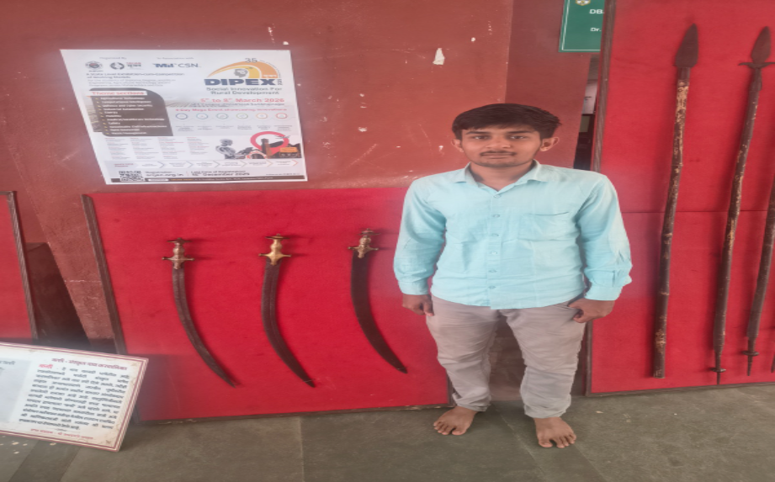

Name: Ajinkya Satish Karale
PRN No.: 2503033111612029
Branch: Mechanical Engineering
Year: First Year

